Materials and methods:
Protein expression and purification for NMR and CD studies
Unlabeled and ¹⁵N isotopically enriched N-terminally acetylated wt aSyn and A124T aSyn were produced by co-transforming E. coli BL21 cells with a plasmid encoding the respective protein gene and a second plasmid encoding the yeast NatB acetyltransferase complex. Both plasmids carried different antibiotic resistance, Ampicillin and Chloramphenicol, to select the doubly transformed E. coli colonies. Purification was carried out as previously reported ¹, with the exception that when required, both antibiotics were included in the growth flasks to avoid plasmid purge during growth and expression. The purity of the final protein preparations was assessed by SDS-PAGE. Purified proteins were dissolved in 20 mM MES buffer containing 100 mM NaCl at pH 6.5 (Buffer A). ¹⁵N-labeled NH₄Cl was obtained from Cambridge Isotope Laboratories, and MES buffer and D₂O were purchased from Merck or Sigma. Protein concentrations were determined spectrophotometrically at 274 nm using an extinction coefficient (ε) of 5,600 M⁻¹ cm⁻¹.

Preparation of SUVs
1,2-Dioleoyl-sn-glycero-3-phosphoethanolamine (DOPE), 1,2-dioleoyl-sn-glycero-3-phospho-L-serine (DOPS), and 1,2-dioleoyl-sn-glycero-3-phosphocholine (DOPC) were obtained from Avanti Polar Lipids (Alabaster, AL) as a DOPE/DOPS/DOPC mixture in a 5:3:2 weight ratio (Coagulation Reagent I). Phospholipid samples containing Coagulation Reagent I were prepared by evaporating chloroform from the lipid solutions under a stream of N₂ gas, followed by re-suspension of the resulting lipid film in Buffer A ². Small unilamellar vesicles (SUVs) were produced by pulse sonication of the phospholipid suspensions using a bath sonicator (10 cycles of 2 min, with 2 min cooling intervals). The hydrodynamic radii of the resulting SUVs (40–50 nm) were determined by dynamic light scattering with a Zetasizer Nano ZS instrument (Malvern Instruments, Worcestershire, U.K.).

Far-UV circular dichroism (CD)
The α-helical content of α-synuclein (aSyn) monomers upon binding to SUVs was evaluated using far-UV circular dichroism (CD) spectroscopy. Solutions containing 10 μM aSyn monomer were analyzed at 25 °C in the absence or presence of increasing SUV concentrations (SUV composition: 20% DOPC, 50% DOPE, and 30% DOPS). Far-UV CD spectra were recorded from 200 to 250 nm using a J-1500 CD spectrophotometer (JASCO, Inc.) with a 0.1 cm quartz cuvette (bandwidth = 1 nm; scan rate = 50 nm min⁻¹; accumulations = 3). The ellipticity at 222 nm was measured, and background contributions from buffer or SUV solutions were subtracted.
The mean residue molar ellipticity at 222 nm ([θ]_{MR, 222}) was calculated according to Equation 1:
${\left[θ\right]}_{MR, 222}= {{\left[θ\right]}_{222}}/{(10Cnl)}$ (1)
where [θ]₂₂₂ is the measured ellipticity (in millidegrees) at 222 nm, C is the protein concentration (in molar units), n = 140 is the number of amino acid residues in the protein, and l is the path length of the cuvette in cm (0.1 cm).
Lipid titration curves were obtained by plotting [θ]_{MR, 222} as a function of lipid concentration and analyzed by fitting the data to Equation 2, as previously described.⁹
${R=R}_{0}-\left(R_{0}-R_{f}\right)\frac{R_{d}+C+L/N-\sqrt{{\left(K_{d}+C+L/N\right)}^{2}-{4CL}/N}}{2C}$ (2)
where R is the measured [θ]_{MR, 222} at a given lipid concentration, R₀ is [θ] _{MR, 222} in the absence of lipid, R_{f} is [θ] _{MR, 222} in the presence of saturating lipid, L is the total lipid concentration, C is the total protein concentration, K_{d} is the apparent macroscopic dissociation constant, and N represents the binding stoichiometry (lipids/protein).

NMR Experiments
NMR spectra were recorded on a Bruker 600 MHz HD Avance III spectrometer equipped with a triple resonance inverse (TCI) ¹H (¹³C/¹⁵N) probe. One-dimensional (1D) ¹H-NMR experiments were acquired at 15 °C using 100 µM unlabeled aSyn samples dissolved in Buffer A. Two-dimensional (2D) ¹H–¹⁵N heteronuclear single quantum correlation (HSQC) spectra were obtained using pulsed-field gradient–enhanced pulse sequences on 100 µM ¹⁵N-labeled protein samples in Buffer A at 15 °C.¹² No aggregation was detected under these conditions due to the low temperature and absence of stirring. Mean weighted chemical shift displacements (MW ¹H–¹⁵N ΔCS) were calculated as [(Δδ₁ᴴ)² + (Δδ₁⁵ᴺ/25)²]¹ᐟ² ³. Pulse field gradient (PFG)-NMR experiments were performed at 15 °C using 100 µM unlabeled aSyn samples dissolved in D₂O and containing dioxane as an internal hydrodynamic radius standard (2.12 Å) and viscosity probe. A series of 20 one-dimensional spectra were collected as a function of gradient amplitude, which was linearly varied from 1.69 to 33.72 G·cm⁻¹. NMR data acquisition and processing were carried out using TOPSPIN 7.0 (Bruker BioSpin, Billerica, MA, USA), and 2D spectra analysis and visualization were performed with CCPN (Collaborative Computational Project for NMR).

Expression and purification of recombinant human WT and A124T aSyn
The bacterial plasmid encoding WT aSyn was modified to generate the p.K58N variant using site-directed mutagenesis (QuikChange II, Agilent), with successful mutagenesis confirmed by Sanger sequencing. The expression and purification of WT and A124T aSyn was performed as previously described ⁴. Briefly, both proteins were expressed in BL21(DE3) E. coli strain transformed with corresponding bacterial expression pET21A vectors encoding either WT or A124T aSyn, followed by proteins extraction and purification by sequential anion-exchange and size-exclusion chromatography. Following purification, the proteins were concentrated, sterile-filtered, aliquoted, and stored at −80°C until use in aggregation assays, and turbidity measurments. Protein concentrations were determined by measuring absorbance at 280 nm using a NanoDrop spectrophotometer and an extinction coefficient of 5,960 M⁻¹ cm⁻¹.

In vitro thioflavin T fluorescence-based aggregation assays
The aggregation kinetics of recombinant human WT and A124T aSyn were monitored using thioflavin T (ThT) fluorescence assay. Before initiating the aggregation assay, purified aSyn samples were centrifuged at 17,000 × g for 30 minutes at 4°C, and the supernatant was diluted to a final protein concentration of 50 µM in a 400-µL master mix containing 25 µM ThT in PBS (pH 7.4). A 100-µL aliquot of each reaction mixture was loaded in triplicate into Costar black, clear-bottom 96-well half-area plates, with a single 1-mm glass bead preloaded into each well, and protein-free master mix was included as a blank. After sealing with microplate sealing tape, the plate was placed in a CLARIOstar Plus microplate reader (BMG Labtech, Ortenberg, Germany) and incubated at 37°C, with the following settings: orbital shaking at 400 rpm for 60 s followed by 30 s without shaking. Measurements were acquired in 3-min cycles for a total of 1,000 cycles. ThT fluorescence was measured at the end of each cycle using bottom optics, with excitation at 450 ± 10 nm and emission at 480 ± 10 nm. The resulting aggregation curves were corrected by subtracting the corresponding blank signal and normalized to the maximum fluorescence value of each run.

Turbidity measurements
100 µM aSyn species were incubated with 15% (w/v) polyethylene glycol (PEG, BP233, Fisher Bioreagents) and 2 mM CaCl₂ (C3306, Sigma) in HEPES buffer (pH 7.4, 6763, Roth) in a final volume of 100 µL. Absorbance was monitored at 350 nm at 25°C under quiescent conditions using a half area black clear-bottom plate (3881, Corning) in an Infinite M200 Pro (Tecan) microplate reader. Measurements were recorded at 5, 30, and 60 min after PEG addition. Data were obtained from three independent experiments.

Plasmids
The cDNAs encoding full-length human SNCA and VAMP2, corresponding to aSyn and VAMP2, respectively, were obtained from human SH-SY5Y neuroblastoma cells and cloned into the pEYFP-N1 and pMD2.G vectors (Addgene plasmids #96808 and #12259, respectively). The resulting constructs encoded aSyn fused to a C-terminal YFP tag and VAMP2 fused to a C-terminal FLAG tag. The aSyn A124T variant was generated using the KLD site-directed mutagenesis protocol (M0554S, New England Biolabs, Ipswich, MA, USA). All plasmid sequences were verified by DNA sequencing. The 5HT6-YFP-Inpp5e plasmid was obtained from T. Inoue (Addgene plasmid #96808; RRID: Addgene_96808), and pMD2.G was obtained from D. Trono (Addgene plasmid #12259; RRID: Addgene_12259)

Cell culture and transfection
HeLa cells (ECACC 93021013) were cultured and maintained in high glucose Dulbecco’s modified Eagle’s Medium (DMEM) (31966-021, Gibco) containing 10% fetal bovine serum (FBS, F7524, Sigma) and 1% Penicillin/Streptomycin (P0781, Sigma) at 37°C in a humidified atmosphere containing 5% CO₂. Cells were routinely screened for mycoplasma contamination using MycoStrip™ (InvivoGen, Toulouse, France). For confocal imaging, the cells were seeded at 20,000 cells/well using 8-well ibidi dishes (80807, ibidi, Gräfelfing, Germany) or in 48-well Cellstar plates (677 180, Greiner Bio-One) for Incucyte experiments. After overnight incubation, Transfection was carried using FuGENE HD (E2311, Promega) according to the manufacturer’s instructions. Each reaction consisted of 250 ng DNA and 0.75 µL FuGENE HD diluted in 12.5 µL Opti-MEM and incubated for 15 min at room temperature. The transfection mixture was then added to the cells, followed by 300 µL complete medium, and imaging was performed 24 h later.

Confocal microscopy and IncuCyte
Live-cell confocal imaging was performed using an LSM 780 confocal microscope (Zeiss, Oberkochen, Germany) equipped with a 63× oil-immersion objective. YFP fluorescence was excited with a 514-nm laser at 2% power, and images were processed using ZEN 2.3 Black Edition and ZEN 2.6 Blue Edition. To quantify condensate formation, cells were imaged using the Incucyte S3 live-cell analysis system (Essen BioScience, Newark, UK). Phase-contrast and green-fluorescence images were acquired every 4 h using a 20× objective and a 200-ms exposure. Condensate formation was quantified 16 h after transfection as the percentage of cells exhibiting condensate formation, using IncuCyte 2021A for data analysis. At least three biological replicates with three technical replicates each were analyzed in a blinded manner.

Quantification and statistical analysis
Data were analyzed using Microsoft Excel 2016 and GraphPad Prism 9.3.1 and are presented as mean ± SEM unless stated otherwise. Statistical comparisons were done using unpaired two-tailed t-test, with Exact p-values and relevant statistical parameters are provided in the Fig.s and the corresponding Fig. Legends. The data were assumed to be normally distributed, but this was not formally tested. We have not used any statistical methods to pre-determine sample sizes, but sample sizes were selected based on previous studies. Samples were randomly assigned to experimental groups, and data collection and analysis were performed blinded to the experimental condition where indicated. Experiments were included in the analysis only when the WT control displayed appropriate condensate formation.

Solubility and dynamic pS129 reversibility experiments
Plasmids and lentivirus production: To generate the expression constructs, synthetic cDNA sequences encoding WT or A124T aSyn were digested with SpeI and NotI and ligated into the pLVX-EF1α-IRES-ZsGreen1 vector (TaKaRa). Expression of the inserted αSyn sequences was driven by the EF1α promoter. Lentiviral particles were produced in 293T cells as previously described ⁵. Briefly, cells were co-transfected with plasmids encoding WT or A124T aSyn together with the packaging plasmids pMD2.G and psPAX2 (Addgene plasmid nos. 12259 and 12260, respectively). Following transfection, viral particles were collected from the culture supernatant and concentrated by ultracentrifugation at 100,000g. Following ultracentrifugation, the purified viral pellet was resuspended in neurobasal medium supplemented with B-27 and GlutaMAX (Gibco), resulting in an approximate concentration of 2·5x10⁶ viral particles per μL. To examine the impact of the A124T mutation on phosphorylation of aSyn at S129, primary cortical neurons obtained from E18 pregnant SNCA knockout (SNCA−/−) rats were cultured in 24-well plates pre-coated with poly-D-lysine, and human WT or A124T aSyn expression was induced by lentiviral transduction at day in vitro 5 (DIV5), as previously described ⁶. To assess whether the A124T substitution alters aSyn solubility, cytosolic (C) and membrane-associated (M) protein fractions were isolated by sequential protein extraction using the on-plate extraction method described previously ⁷. For experiments examining the dynamic reversibility of aSyn phosphorylation at S129, cortical cultures were treated at DIV17-21 were exposed to vehicle (DMSO), 20 µM picrotoxin (PTX), 1 µM tetrodotoxin (TTX), or a combination of PTX and TTX. After 2 or 4 h of treatment, cells were lysed and analyzed by immunoblotting to quantify total aSyn and pS129 aSyn levels, as previously described ^{5,6}. A minimum of three independent experiments was performed on separate days, with 10–16 biological replicates analyzed in total. Statistical analysis of the data presented in Fig. 6B, D, and I–L was performed using an unpaired t‐test with Welch's correction. Data in Fig. 6F–G were analyzed using Brown–Forsythe and Welch one-way ANOVA followed by Dunnett’s T3 post hoc test for multiple comparisons, whereas data presented in Fig. 6H were analyzed using two-way ANOVA followed by Šídák’s multiple-comparisons test.

Yeast plasmids, strains and growth conditions
Yeast plasmids used in the study are listed in Table 1. Yeast strain W303-1a (MATa; ura3-1; trp1Δ 2; leu2-3,112; his3-11,15; ade2-1; can1-100) was used for transformations performed using the standard lithium acetate protocol. Yeast strains were grown at 30°C in synthetic complete dropout (SC) medium lacking uracil and supplemented with either 2% raffinose or 2% galactose. Expression of GAL1-αSyn-GFP was induced by shifting overnight cultures grown in 2% raffinose to 2% galactose-containing SC selection medium at A₆₀₀ = 0.1. Plasmid pBP702 harboring A124T-GFP was generated by site-directed mutagenesis.

Spotting assays
Yeast cells were pre-grown in selective SC medium containing 2% raffinose. Cells were normalized to equal densities, serially diluted 10-fold starting with an OD₆₀₀ of 0.1, and spotted onto SC-Ura plates containing either 2% glucose or 2% galactose. After 3 days of incubation at 30°C, plates were photographed.

Immunoblotting
Overnight cultures of yeast strains were grown in SC-Ura medium containing 2% raffinose. For induction of the GAL1 promoter, cells were inoculated in SC-Ura medium containing 2% galactose to an OD₆₀₀ = 0.1 and incubated for 6 h. Whole-cell protein extracts were prepared under denaturing conditions by alkaline lysis followed by trichloroacetic acid (TCA) precipitation. Western blot analysis was performed using standard procedures using anti-αSyn antibody (1:2000, BD Transduction Laboratory, USA) or anti-GAPDH antibody (1:5000, ThermoFisher Scientific, USA) as loading control.

Fluorescence microscopy and quantifications
Yeast cell were grown in SC-Ura medium containing 2% raffinose until mid-log phase and transferred to SC-Ura medium supplemented with 2% galactose. Expression was induced for 6 h and fluorescent images were obtained with Zeiss Observer. Z1 microscope equipped with CSU-X1 A1 confocal scanner unit (YOKOGAWA), QuantEM:512SC (Photometrics) digital camera and SlideBook 5.0 software package (Intelligent Imaging Innovations). For quantification of aggregation at least 100 cells were counted per strain and per experiment.

SAXS experiments
Lipid vesicles (LVs) mimicking the size, phase state and charge distribution of synaptic vesicles were prepared in PBS from 55 mol% 1,2-dioleoyl-sn-glycero-3-phospho-choline (DOPC), 20 mol% 1,2-dioleoyl-sn-glycero-3-phospho-L-serine (DOPS), 15 mol% 1,2-dioleoyl-sn-glycero-3-phosphoethanolamine (DOPE) and 10 mol% cholesterol by 10 freeze-thaw cycles and extrusion through a polycarbonate membrane of 50 nm pore size using an Avanti Mini Extruder (Avanti Research, AL, USA), as previously described ^{10, 11}.
SAXS experiments were carried out at the BM29¹² beamline (BioSAXS) of the ESRF in Grenoble. The synchrotron beam was collimated and subsequently monochromatized to 12.5 keV by a double multilayer monochromator. The beam was further focused by a 4 mrad toroidal mirror to a beam size of about 150 × 150 μm² with a flux of approximately 10¹³ photons/s at the sample position. SAXS data was recorded using a Pilatus3 2M single-photon counting pixel detector (DECTRIS, Baden-Dättwil, Switzerland) in a vacuum flight tube. The sample to detector distance was 2.823 m. The primary beam was blocked by a beamstop just in front of the detector. The samples were mixed in PCR tubes prior to the measurements, for which they were injected into a 1 mm diameter quartz capillary by an automated sample changer robot. Before and after the measurement of each sample, measurements on PBS buffer were executed in order to secure a precise background subtraction. Each measurement consisted of 10 frames of 1 s of exposure each while the sample was flowing through the capillary to mitigate radiation damage. The measurement temperature was set to 24 °C. The azimuthal integration of the 2D scattering images was performed by the data processing software of BM29¹⁴. The scattering intensity I(q) was calibrated with pure water, which allows to express it in absolute units cm⁻¹, where q is the scattering vector in nm⁻¹. All data is available under https://doi.esrf.fr/10.15151/ESRF-ES-2457160090 (beamtime MX-2851).
After averaging the I(q) curves of different frames, the background curves were subtracted. For the fitting, the vesicle lipid bilayer is modeled as an electron density profile (EDP) $ρ\left(z\right)$ consisting of three Gaussian functions:
$$ρ\left(z\right)=\sum_{i=1}^{3}{ρ_{i}exp\left[-\frac{{\left(z-z_{i}\right)}^{2}}{2σ_{i}^{2}}\right],}$$
with the peak amplitudes $ρ_{i},$ peak positions $z_{i}$ and the Gaussian widths $σ_{i}$. For all fits, $z_{1}=z_{3}≡z_{h}$ and $z_{2}≡0$, i.e. the head group distances from the bilayer midplane were set equal for the two leaflets. Since only the ratios, not the absolute values of the amplitudes $ρ_{i}$ determine the scattering curve (up to a scaling of intensity), we set $ρ_{2}≡-1$. On the larger scale, the vesicles are modeled as polydisperse perfect spheres with a radius R and a Gaussian polydispersity function with a width $σ_{R}$. Relying on Brzustowicz and Brunger¹³, we have an approximate model function without numerical computation at our disposal:
$$F_{\text{sphere}}\left(q\right)=\frac{1}{q^{2}}\sum_{i=1}^{3}{\sum_{j=1}^{3}{ρ_{i}ρ_{j}σ_{i}σ_{j}}}exp\left[-\frac{q^{2}\left(σ_{i}^{2}+σ_{j}^{2}\right)}{2}\right][A_{ij}(q) - B_{ij}(q) +C_{ij}(q)]$$
with
$$A_{ij}\left(q\right)=\left[\left(R+z_{i}\right)\left(R+z_{j}\right)+σ_{R}^{2}\right]\cos\left[q\left(z_{i}-z_{j}\right)\right],$$
$$B_{ij}\left(q\right)=\left[\left(R+z_{i}\right)\left(R+z_{j}\right)+σ_{R}^{2}-4q^{2}σ_{R}^{4}\right]\cos\left[q\left(2R+z_{i}+z_{j}\right)\right]\exp\left(-2q^{2}σ_{R}^{2}\right),$$
$$C_{ij}\left(q\right)=2qσ_{R}^{2}\exp\left(-2q^{2}σ_{R}^{2}\right)\left(2R+z_{i}+z_{j}\right)\sin\left[q\left(2R+z_{i}+z_{j}\right)\right].$$
The spherical model with asymmetric EDP convincingly captures all important features of the SAXS data, except for the low-q region, possibly due to the presence of larger particles (lipid aggregates) which would manifest themselves in this q-range.

Table 1. Yeast plasmids used in this study.
Name | Description | Source
p426 | 2µ, URA3, GAL1^{pr}, CYC1^{term}, AmpR | ⁸
pME3763 | p426-GAL1^{pr}::SNCA::GFP | ⁹
pBP702 | p426-GAL1^{pr}::SNCA(A124T)::GFP | This study

References

1. Buratti FA, Boeffinger N, Garro HA, Flores JS, Hita FJ, Gonçalves P do C, et al. Aromaticity at position 39 in α-synuclein: A modulator of amyloid fibril assembly and membrane-bound conformations. Protein Science. 2022;31(7). doi:10.1002/pro.4360
2. Maltsev AS, Ying J, Bax A. Impact of N-terminal acetylation of α-synuclein on its random coil and lipid binding properties. Biochemistry. 2012;51(25). doi:10.1021/bi300642h
3. Cavanagh J, Fairbrother WJ, Palmer AG, Rance M, Skelton NJ. Protein NMR Spectroscopy: Principles and Practice. Protein NMR Spectroscopy: Principles and Practice. 2006. doi:10.1524/zpch.1997.202.part_1_2.297
4. Al-Azzani M, König A, Outeiro TF. Production of Recombinant Alpha-Synuclein: Still No Standardized Protocol in Sight. Biomolecules. 2022 Feb 18;12(2):324. doi:10.3390/biom12020324
5. Ramalingam N, Jin SX, Moors TE, Fonseca-Ornelas L, Shimanaka K, Lei S, et al. Dynamic physiological α-synuclein S129 phosphorylation is driven by neuronal activity. NPJ Parkinsons Dis. 2023 Jan 16;9(1):4. doi:10.1038/s41531-023-00444-w
6. Ramalingam N, Brontesi L, Jin S, Selkoe DJ, Dettmer U. Dynamic reversibility of α‐synuclein serine‐129 phosphorylation is impaired in synucleinopathy models. EMBO Rep. 2023;24(12). doi:10.15252/embr.202357145
7. Ramalingam N, Dettmer U. Temperature is a key determinant of alpha- and beta-synuclein membrane interactions in neurons. J Biol Chem. 2021;296:100271. doi:10.1016/j.jbc.2021.100271 PubMed PMID: 33428933.
8. Mumberg D, Muller R, Funk M, Müller R, Funk M. Regulatable promoters of Saccharomyces cerevisiae: comparison of transcriptional activity and their use for heterologous expression. Nucleic acids research. 1994/12/25. 1994 Dec 25;22(25):5767–8. PubMed PMID: 7838736.
9. Petroi D, Popova B, Taheri-Talesh N, Irniger S, Shahpasandzadeh H, Zweckstetter M, et al. Aggregate clearance of alpha-synuclein in Saccharomyces cerevisiae depends more on autophagosome and vacuole function than on the proteasome. J Biol Chem. 2012/06/23. 2012;287(33):27567–79. doi:M112.361865 [pii] 10.1074/jbc.M112.361865 PubMed PMID: 22722939.
10. Milovanovic D, Wu Y, Bian X, De Camilli P. A liquid phase of synapsin and lipid vesicles. Science. 2018;361(6402):604-607. doi:10.1126/science.aat5671
11. Alfken J, Neuhaus C, Major A, Taskina A, Hoffmann C, Ganzella M, Petrovic A, Zwicker D, Fernández-Busnadiego R, Jahn R, Milovanovic D, Salditt T. Vesicle condensation induced by synapsin: condensate size, geometry, and vesicle shape deformations. Eur Phys J E Soft Matter. 2024;47(8). doi:10.1140/epje/s10189-023-00404-5
12. Tully MD, Kieffer J, Brennich ME, Cohen Aberdam R, Florial JB, Hutin S, et al. BioSAXS at European Synchrotron Radiation Facility – Extremely Brilliant Source: BM29 with an upgraded source, detector, robot, sample environment, data collection and analysis software. Journal of Synchrotron Radiation. 2023;30(1):258–266. doi:10.1107/S1600577522011286
13. Brzustowicz MR, Brunger AT. X-ray scattering from unilamellar lipid vesicles. Journal of Applied Crystallography. 2005;38(1):126–131. doi:10.1107/S0021889804029206
14. Kieffer J, Brennich M, Florial JB, Oscarsson M, de Maria Antolinos A, Tully M, et al. New data analysis for BioSAXS at the ESRF. J Synchrotron Radiat. 2022;29(Pt 5):1318–1328. doi:10.1107/S1600577522007238 PubMed PMID: 36073892.

Supplementary figures
Figure S1.
Fig. S1. ¹H NMR of methionine and tyrosine side chains in WT and A124T aSyn monomers. ¹H NMR spectra of methionine (A) and tyrosine (B) side chains in WT (black) and A124T aSyn (red) proteins. Spectra were recorded at 15 °C in Buffer A using samples containing 100 µM WT and A124T aSyn. Changes are observed on the Tyr-125 and Met-127 resonances, induced by the mutation at position 124 of the protein sequence.

Figure S2.
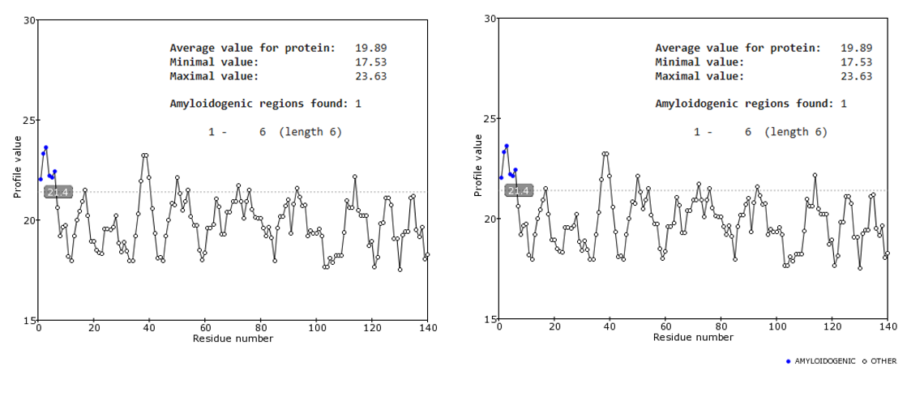
Fig S2. Prediction of the impact of the A124T mutation on aggregation properties of aSyn. Prediction of amyloidogenic sequences of WT (left) and K58N (right) aSyn through FoldAmyloid tool based on the probability of formation of hydrogen bonds.

Table. 1 Evaluation of the effect of K58N using PASTA 2.0 algorithm
Parameter | WT | A124T
Length | 140 | 140
# Amyloids | 20 | 20
Best energy | −7.239327 | −7.239327
Disorder (%) | 34.28 | 34.28
α-helix (%) | 26.43 | 24.29
β-strand (%) | 22.14 | 24.29
Coil (%) | 51.43 | 51.43

Table S2. Linear fit statistics for aSyn WT
 | R² | $$χ_{\text{red}}^{2}$$ | F | p
Total EDP integral | 0.83 | 0.23 | 43.11 | 1.03×10⁻⁴
Head groups EDP integral | 0.11 | 3.25 | 1.15 | 0.31
Tail group EDP integral | 0.14 | 19.27 | 1.42 | 0.26
Head groups EDP asymmetry | 0.98 | 0.07 | 368.47 | 1.30×10⁻⁸
Head to tail EDP ratio | 0.87 | 0.16 | 60.39 | 2.79×10⁻⁵
Head group position $z_{h}$ | 0.42 | 101.18 | 6.44 | 0.03
Fitted radius R | 0.25 | 0.46 | 3.02 | 0.12
Polydispersity $σ_{R}$ | 0.88 | 1.40 | 67.59 | 1.78×10⁻⁵

Table S3. Linear fit statistics for aSyn A124T
EDP metric | R² | $$χ_{\text{red}}^{2}$$ | F | p
Total EDP integral | 0.88 | 0.12 | 58.32 | 6.09×10⁻⁵
Head groups EDP integral | 0.31 | 0.97 | 3.52 | 0.10
Tail group EDP integral | 0.01 | 5.09 | 0.12 | 0.74
Head groups EDP asymmetry | 0.90 | 0.07 | 71.17 | 2.97×10⁻⁵
Head to tail EDP ratio | 0.89 | 0.12 | 65.43 | 4.03×10⁻⁵
Head group position $z_{h}$ | 0.87 | 13.26 | 54.07 | 7.97×10⁻⁵
Fitted radius R | 0.44 | 0.03 | 6.21 | 0.04
Polydispersity $σ_{R}$ | 0.96 | 0.38 | 205.44 | 5.48×10⁻⁷

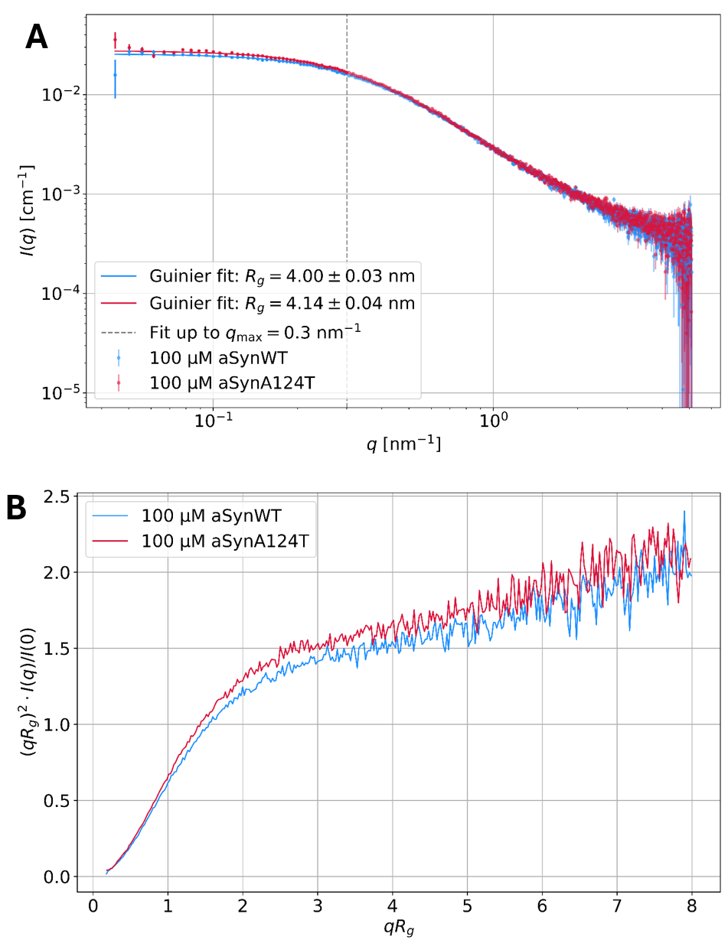
Figure S3.
Fig S3. Protein SAXS curves of 100 µM WT aSyn and aSyn A124T in PBS. (A) shows Guinier fits which lead to similar radii of gyration $R_{g}$ for WT aSyn and aSyn A124T (ca. 4 nm and 4.1 nm respectively). The dimensionless Kratky plot in (B) indicates that both variants are unfolded in solution.

